Mini Project: Project Ideation

Name: Francis Roel L. Abarca Cohort: BDSE07-UIF

1. Understand the overview of the Community Portal from Project Mentor.

|  |  |  |
| --- | --- | --- |
| No | Questions | Answers |
| 1 | What is the purpose of the community portal? | The purpose of the community portal is for the user whether its someone looking for a job or someone doing research for someone’s job expertise for hiring, it is easy and convenient to view all the information needed. |
| 2 | What important information you want the user to provide with inside the Community Portal? | I want to provide the list of available jobs in the area, recent hirings, user experience history and performance ratings on previous jobs. |
| 3 | LinkedIn can already do a similar thing to this, in what aspect does your Community Portal set apart from LinkedIn? | The main thing that sets my community portal apart from LinkedIn is with its integration with GitHub and LinkedIn itself. It automatically aggregates all information you have on LinkedIn and GitHub and shows them on your profile for students to see especially the GitHub Contributions Chart. |
| 4 | What will the user’s ideal experience to visit the Community Portal? | The user’s ideal experience to visit the community portal is to be able to view the list of available jobs and the user’s profiles easily and efficiently. |
| 5 | Will this website be easy to use? | Absolutely. This website is designed with simplicity in mind and shows only the relevant information and buttons needed for the user to use. |

1. Persona

List the different personas who will be using the Community Portal, with brief description of each of the personas.

|  |  |  |
| --- | --- | --- |
| No | Persona | Brief Description |
| 1 | Peter Muller | Software Engineering graduate looking for a job. |
| 2 | Aaron Peterson | Head of the Human Resources Department responsible for employing people. |
| 3 | Carol Moore | Has 6 years of Networking Engineer and wants to create a job profile. |
| 4 | Ben Michaud | Just recently finished working at a company and wants to update his current job profile. |

1. Create a Personas profile with Demographics, Behaviors & Beliefs, Characteristics & Goals for 2 Personas defined.

|  |  |
| --- | --- |
| Persona (1): | Peter Muller |
| Demographics: | 24, Male, Software Engineering Graduate |
| Behaviors and Beliefs: | Has great collaboration skills, |
| Characteristics: | Hardworking, Innovative and Reliable |
| Goals: | Find a new job and effectively engage with the HR teams on big companies. |

|  |  |
| --- | --- |
| Persona (2): | Aaron Peterson |
| Demographics: | 32, Male, Head of the Human Resources Department |
| Behaviors and Beliefs: | Has great work experience, believes in worker’s experience and an expert in communications. |
| Characteristics: | Loyalty, Friendly, and Communicative |
| Goals: | Evaluate and Recruit Employees through the site. |

1. Conduct Ideation for the Project Scenario and come up with 2 Ideas to meet the Project Scenario

Scenario Name: Creating a new User Profile

|  |  |
| --- | --- |
| No | Ideas |
| 1 | Create a sign-up page on the side. The user clicks on the Log-in button located at the upper right corner of the page which leads to the Log-in page where the user can log in or register his/her account. The Sign-up form is located on the side which is semi transparent with a photo background at the back for a modern look. |
| 2 | Create a sign-up page that floats on top the home page then allows the user to log in and register without leaving the Home Page itself. |

1. Create Scenario & Storyboard for one of the Scenarios

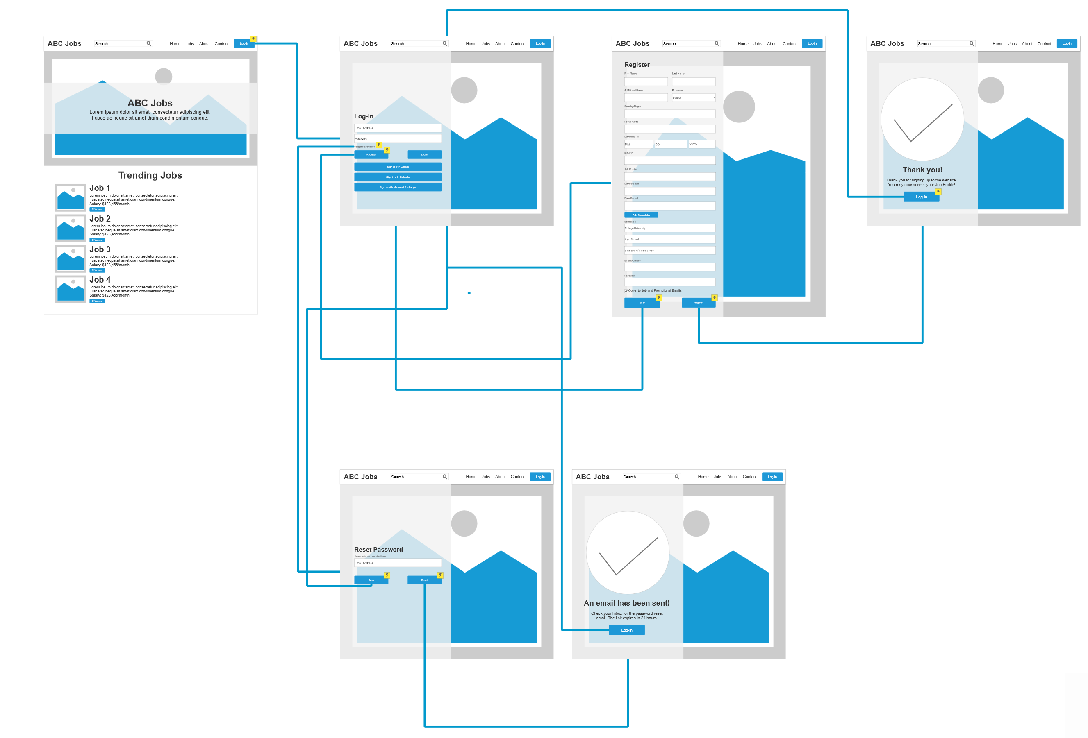

1. Use Axure to Create a Wireframe Prototype for 1 Scenario Scenario Name: Creating a Job Profile

|  |  |
| --- | --- |
| Wireframe pages | Specifications (Widget Table) |
|  | |  |  |  | | --- | --- | --- | | Note No. | Name | Note | | 1 | Company Banner | Banner of ABC Jobs | | 2 | Search Bar | For searching relevant information on the portal | | 3 | Home | Shows the main website with relevant information. | | 4 | Jobs | Shows a list of Jobs available | | 5 | About | Shows the About page | | 6 | Contact | Shows the Contact Info for ABC Jobs | | 7 | Log-in | Allows the user to log-in and register onto the site. | | 8 | Check-out | Allows the user to check-out on a field of interest. | |
|  | |  |  |  | | --- | --- | --- | | Note No. | Name | Note | | 1 | Email Address Bar | Lets the user input their Email Address | | 2 | Password Bar | Lets the user input their Password. | | 3 | Register | Allows the user to create an account | | 4 | Log-in | Allows the user to log-in to an account | | 5 | Forgot Password | Allows the user to reset their password in case its forgotten. | | 6 | Sign in with GitHub | Allows the user to log-in to their ABC Jobs account using their GitHub account. | | 7 | Sign in with LinkedIn | Allows the user to log-in to their ABC Jobs account using their LinkedIn account. | | 8 | Sign in with Microsoft Exchange | Allows the user to log-in to their ABC Jobs account using their Microsoft Exchange/Office 365 account. | |
|  | |  |  |  | | --- | --- | --- | | Note No. | Name | Note | | 1 | First Name | Lets the user input their First Name | | 2 | Last Name | Lets the user input their Last Name | | 3 | Additional Name | Lets the user input their Additional Name (i.e. Sr, Jr, III) | | 4 | Pronouns | Lets the user specify their own pronouns (i.e. He, She, They/Them, Non-binary, others) | | 5 | Country/Region | Allows the user to specify their Country of origin. | | 6 | Postal Code | Allows the user to specify their postal code. | | 7 | Date of Birth | Allows the user to enter their date of birth. | | 8 | Industry | Allows the user to specify their job industry. | | 9 | Job Position | Specifies the Job Position. | | 10 | Date Started | Specifies the date start of the job. | | 11 | Date Ended | Specifies the date end of the job. | | 12 | Add More Jobs | Allows the user to add more jobs. | | 13 | Education | Allows the user to specify their Elementary, High School and College educational background. | | 14 | Email Address | Allows the user to enter their Email Address. | | 15 | Password | Allows the user to specify their password. | | 16 | Opt-in to job and promotional emails | Allows the user to opt in for emails related to job applications and promotional emails. | | 17 | Register button | Allows the user to register their information. | |
|  | |  |  |  | | --- | --- | --- | | Note No. | Name | Note | | 1 | Log-in | Allows the user to log-in and register onto the site. | |
|  | |  |  |  | | --- | --- | --- | | Note No. | Name | Note | | 1 | Profile Banner | Banner of ABC Jobs | | 2 | Profile Picture | For searching relevant information on the portal | | 3 | Name | Shows the main website with relevant information. | | 4 | Description | Shows a list of Jobs available | | 5 | Edit Profile button | Allows the user to modify their profile. | | 6 | Timeline tab | Shows the About page | | 7 | GitHub Contributions Tracker | Shows their GitHub Contributions in the page. | | 8 | Job History | Shows the user’s current job history. | | 9 | Posts tab | Shows the Contact Info for ABC Jobs | | 10 | About tab | Allows the user to log-in and register onto the site. | | 11 | Similar People | Allows the user to check-out on a field of interest. | |

7. Plan the Implementation for the Project Scenario

|  |  |
| --- | --- |
| Priorities | Scenario |
| Top | Home  Registration Form  Sign in Form  About Page  Profile Page  Contacts Page |
| Medium | GitHub Account Integration  LinkedIn Account Integration  Office 365 Integration  Google Enterprise Integration |
| Nice to have | Mobile App  Two Factor Authentication support |